Townlands C of E Primary Academy
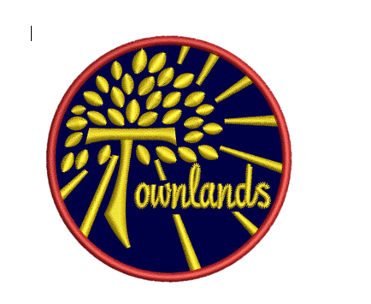
“A journey of learning in the light of God’s love”
Faith, Honesty, Love, Friendship, Forgiveness, Hope, Respect
“What shall we say the Kingdom of God is like, or what parable shall we use to describe it? It is like a mustard seed which is the smallest seed you plant in the ground. Yet when planted, it grows and becomes the largest of all garden plants, with such big branches that the birds of the air can perch in its shade.”
The parable of the Mustard seed- Mark 4:30-32
EYFS Summer Term 2026 First Half Term
STAFF: Mrs Greenaway, Mrs Thomas and Miss Bell

Welcome back! We hope you have all had a lovely Easter break and are ready for the final term of the children’s first school year. There is much learning still to come over the next 6 weeks in preparation for year 1.
This half term’s driving question is ‘Who can help me in our local community?’
We’ve all heard and read about superheroes…they wear big pants, have super powers and can sometimes even fly. But have you ever stopped to think about who the real life superheroes are? We’re going to explore how people in our local community can help us, from firefighters to police officers, doctors and nurses to dentists and vets. There’s somebody out there able to offer us assistance in solving every problem we might encounter.

Books we will be using to enhance our learning and love of reading.


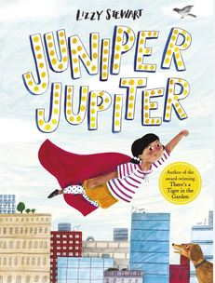
Juniper Jupiter – Lizzy Stewart
Juniper Jupiter is a superhero and, like most superheroes, she feels the need to find a sidekick. When she decides to interview potential candidates - so many people turn up - but no one is exactly right for the role.
After much searching, Juniper finds her perfect sidekick closer to home than she ever anticipated.
A Superhero Like You – Dr Ranj
Lily knows exactly what she wants to be when she grows up: a superhero! But she's not interested in being a silly superhero. She doesn't want to wear her pants outside her trousers! Lily wants to be a REAL superhero: the kind who helps people and makes the world a better place.
Join Lily as she meets the extraordinary superheroes all around us, from doctors, teachers and air ambulance paramedics to scientists, recycling truck drivers and carers. Discover the amazing work these real-life heroes do using their incredible superpowers of kindness, care and love.
Homework
We send your child home with two phonics reading books each week that marry up with their phonics stage. Your support will be much appreciated should they need it, however, your child should be using their phonic knowledge to read independently. At this point in the year you will notice your child reading with more fluency and expression; give them lots of praise! Please encourage the children to read with you at least five times a week and discuss what they have read to support their comprehension. Sign the reading record each day that reading happens to ensure prizes are given as they are earnt.
Additional suggestions for weekly homework activities are on the accompanying sheet. Please upload these onto Tapestry, or bring into school to share on Fridays.

PE
P.E sessions will be with our sports coach, Mr Moon and will continue to take place on Monday afternoons.
Please ensure that your child’s name is written inside each item of clothing brought into school. P.E. lessons may well take place outdoors. This makes returning items at home time so much quicker and easier, thank you!
Health & Safety reminder
No jewellery is to be worn during PE lessons, however if earrings can’t be removed, then they need taping over before school. Long hair must be tied up on Mondays or hair bobbles provided from home please.
On warmer days suncream should be applied at home before school and sunhats should be brought in every day. Only prescription sunglasses are permitted during the school day at playtime and lunch time.

Water 
The children need to continue to bring to school fresh water (not juice) each day in a labelled bottle. It is important they do this to remain hydrated especially in the warmer weather. We thank you for your cooperation with this. Water bottles can easily be re-filled by adults as needed throughout the day.

Dates for your diary
Specific dates and times of any events that arise and other key dates will be confirmed as we move through the term. Currently, we have…
20th May – Special visitors for EYFS
21st May – Whole school Art Day

Information regarding activities and learning in school continue to be added to Tapestry frequently and your interaction with this method of communication has been wonderful this year thus far.
Keep looking the school website for any additional information needed. If you have any queries or questions at any time, then please feel free to phone or email the school office.
Finally, keep an eye on Townland’s Facebook feed for the latest updates and successes.

