October half-term ‘pick and mix’ homework
During our half-term break, why not choose some of the following activities as part of your homework. Remember that reading, TTRS and Numbots are also good activities for you to continue with.
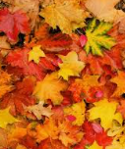  Autumn nature hunt  Find and record examples of shapes, symmetry, or patterns in nature (e.g., leaves, spider webs). | 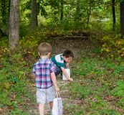  Mindful nature walk  Go for a walk and list or sketch 5 things you noticed that made you feel calm or happy. |   Character interview  Pretend to interview a character from a book you’ve read. What would they say?
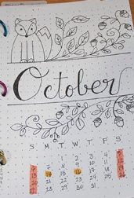  Family Time Log  Record fun or meaningful moments spent with family during the break. | 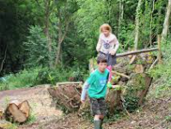  Autumn Obstacle Course  Design and complete an outdoor obstacle course using natural materials. | 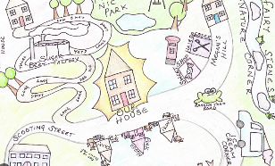  Map Your Walk  Draw a simple map of a walk you took, including landmarks and directions.
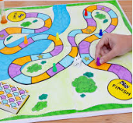  Design a board game  Create a game with rules, a board, and pieces. |   Cooking time  Follow a recipe and measure ingredients. | 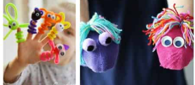  Puppet Show  Make puppets from socks or paper and perform a short play.

