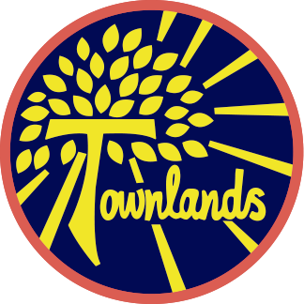

Townlands C of E Primary Academy
“A journey of learning in the light of God’s love”
Faith, Honesty, Love, Friendship, Forgiveness, Hope

“What shall we say the Kingdom of God is like, or what parable shall we use to describe it? It is like a mustard seed which is the smallest seed you plant in the ground. Yet when planted, it grows and becomes the largest of all garden plants, with such big branches that the birds of the air can perch in its shade.”

The parable of the Mustard seed- Mark 4:30-32


Year One Summer 1 2026
Teachers: Miss Bassett & Mrs Bromley

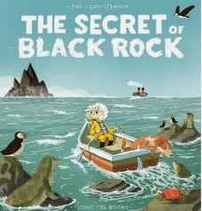
The Secret of Black Rock -The Secret of Black Rock tells the story of Erin, a curious and brave girl who sets out to discover the truth about the mysterious Black Rock.

The children will have the opportunity to retell the story in their own words and write a diary entry from the main character’s perspective, explaining why Black Rock should be saved. This will support their narrative and persuasive writing skills while deepening their understanding of the story’s themes.

This term, children will be learning about the role of a monarch, exploring what kings and queens do and how their responsibilities have changed over time, from ruling countries in the past to the largely ceremonial roles seen today. They will also be investigating castles, discovering their purpose as defensive structures, identifying key features such as towers, moats and drawbridges, and learning how castle designs evolved over time. In science, pupils will focus on seasonal changes, observing how the weather, daylight hours and natural environment change, and how this affects plants, animals and everyday life.

As part of our topic, we are excited to be holding a special Monarch Day, where children are invited to dress as kings, queens, princes or princesses. They will take part in a range of fun activities, including designing their own crowns and coats of arms, alongside many other exciting experiences.

Homework:
Homework is set every Friday and is due in the following Thursday:
• The homework will be maths, reading and spellings
• Maths will be set via MyMaths and Numbots which is online. Login details for both have been sent home
• Spellings are set weekly and tested on Friday
Reading
Your child has a new reading book every week, appropriate to their reading ability. A child should be able to read their book fluently, using expression and show an understanding of what they are reading. We encourage the children to read at least five times a week and discuss what they have read with an adult. A reading record will need to be completed. Reading books will be changed weekly. Reading records will be checked every Monday.
PE:
P.E. will continue to be with our sports coach Mr Moon on Wednesday, and with myself on Friday. It is important that the children come to school in their P.E. kit on these days. This needs to include an outdoor kit which is joggers, sweatshirt and trainers and indoor kit which is shorts, T-shirt and plimsolls.
Health & Safety reminder:
No jewellery to be worn during PE lessons, however if earrings can’t be removed then they need taping over. Children should bring their own tape and long hair tied up.



Water:
The children need to continue to bring to school fresh water (not juice) each day in a labelled bottle. It is important they do this because they do get thirsty throughout the day. We thank you for your cooperation with this.

Keep looking at our pages on the website for information and activities. If you have any queries or questions at any time, then please feel free to phone or email the school office.
Finally, keep an eye on Townlands Facebook page for the latest updates and successes.
Dates for your diary:
Thursday 16th April – Year 1 Monarchy Day
Monday 4th May - Bank Holiday
Friday 8th May – Year 1 Class Assembly
Thursday 21st May – Whole school art day
Monday 8th June – Year 1 class trip Attenborough Arboretum
w/c 8th June – Phonics screening

