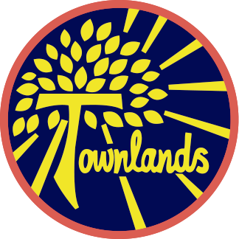

Townlands C of E Primary Academy
“A journey of learning in the light of God’s love”
Faith, Honesty, Love, Friendship, Forgiveness, Hope

“What shall we say the Kingdom of God is like, or what parable shall we use to describe it? It is like a mustard seed which is the smallest seed you plant in the ground. Yet when planted, it grows and becomes the largest of all garden plants, with such big branches that the birds of the air can perch in its shade.”

The parable of the Mustard seed- Mark 4:30-32


Year One Summer 1 2025
Teachers: Miss Bassett & Mrs Bromley

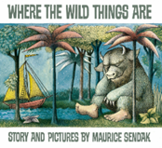
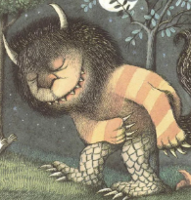
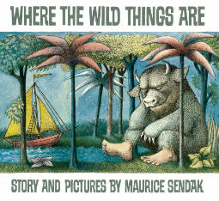
Where The Wild Things Are - By Maurice Sendak
Where the Wild Things Are is a magical story about a boy named Max, who goes on an incredible adventure! After being sent to his room, Max’s imagination takes him to a mysterious island full of wild, strange creatures. He becomes their king and joins in their wild rumpus—but soon, he starts to miss home. This beloved tale by Maurice Sendak is full of adventure, mischief, and the power of imagination.
imagination!
But that’s not all—our young writers will also become expert researchers, creating fascinating information texts about the Wild Things, detailing their appearance, movement, diet, and more! Get ready for a wild and wonderful journey through storytelling and imagination!
We have an exciting half term ahead, packed with fascinating learning opportunities!

In Science, the children will explore the amazing world of animals. They will learn to identify different types of animals—including fish, amphibians, reptiles, mammals, and birds—and investigate what they eat, classifying them as carnivores, herbivores, or omnivores. They’ll also develop their skills in grouping and comparing animals based on their features.

In geography, the children will discover more about our local area, Earl Shilton. They will explore what it’s like to live here, learning about its key features, environment, and community, and compare life in Earl Shilton with other places.

We are looking forward to an inspiring and engaging half term of discovery!

In English, we will be exploring the magical world of Where the Wild Things Are by Maurice Sendak! The children will unleash their creativity by crafting vivid character descriptions and retelling the story in their own words. all—words.

Homework:
Homework is set every Friday and is due in the following Thursday:
• The homework will be maths, reading and spellings
• Maths will be set via MyMaths and Numbots which is online. Login details for both have been sent home
• Spellings are set weekly and tested on Friday
Reading
Your child has a new reading book every week, appropriate to their reading ability. A child should be able to read their book fluently, using expression and show an understanding of what they are reading. We encourage the children to read at least five times a week and discuss what they have read with an adult. A reading record will need to be completed. Reading books will be changed weekly. Reading records will be checked every Monday.
PE:
P.E. is every Wednesday and Friday. It is important that the children come to school in their P.E. kit on these days. This needs to include an outdoor kit which is joggers, sweatshirt and trainers and indoor kit which is shorts, T-shirt and plimsolls.
Health & Safety reminder:
No jewellery to be worn during PE lessons, however if earrings can’t be removed then they need taping over. Children should bring their own tape and long hair tied up.

Water:
The children need to continue to bring to school fresh water (not juice) each day in a labelled bottle. It is important they do this because they do get thirsty throughout the day. We thank you for your cooperation with this.

Keep looking at our pages on the website for information and activities. If you have any queries or questions at any time, then please feel free to phone or email the school office.
Finally, keep an eye on Townlands week in pictures and Facebook for the latest updates and successes.

Dates for your diary:
Tuesday 24th- Wednesday 25th February – Parents evening
Thursday 5th March – World book day and Year 1, 2 & 3 film night
Thursday 12th March – Year 4, 5 & 6 Film night
Monday 9th – Friday 13th – British science week
Friday 20th March – Comic relief ‘Bring a board game’
Tuesday 24th March – Easter church service
Friday 27th March – Easter Bonnet

