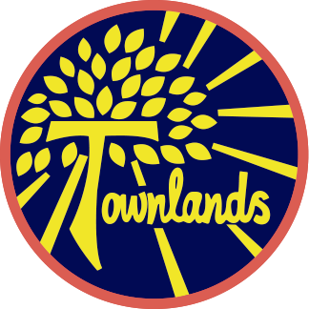

Townlands C of E Primary Academy
“A journey of learning in the light of God’s love”
Faith, Honesty, Love, Friendship, Forgiveness, Hope

“What shall we say the Kingdom of God is like, or what parable shall we use to describe it? It is like a mustard seed which is the smallest seed you plant in the ground. Yet when planted, it grows and becomes the largest of all garden plants, with such big branches that the birds of the air can perch in its shade.”

The parable of the Mustard seed- Mark 4:30-32


Year One Spring Term 1 2026
Teachers: Miss Bassett & Mrs Bromley

We have an exciting half term ahead, packed with fascinating learning opportunities!
In Science, the children will explore the world of everyday materials. They will learn to identify and describe different materials like wood, plastic, metal, and glass. They’ll investigate the properties of these materials—such as whether they are hard or soft, waterproof or not—and discover how materials are used in the things around us.

Meanwhile, in History, we’ll travel through time to explore toys from the past to the present! Children will learn about how toys have changed over the years, comparing old and new toys, and finding out what life was like for children long ago through the toys they played with.

We are looking forward to an inspiring and engaging half term of discovery!

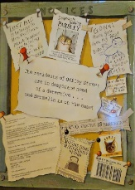
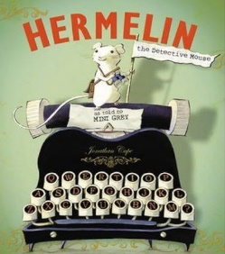
We’ll also step into Hermelin’s shoes (or rather, paws!) to write letters to characters from the book, helping them solve the mystery of their missing items. This will be a fantastic opportunity for the children to practice their letter-writing skills while having lots of fun!
Hermelin by Mini Grey
A tale about an educated Rodent, in this case, a literate mouse, solves a number of minor mysteries in a street of houses. There is also a clever child covering the mysteries and their resolutions. A Holmes and Watson coming together. Amusing and fun! We will also look at other texts written by author, Mini Grey.

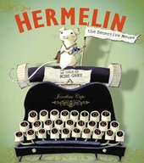
In English, we’ll dive into the wonderful world of Hermelin by Mini Grey. The children will develop their creative writing skills by crafting exciting character descriptions and retelling the story in their own words.

Homework:
Homework is set every Friday and is due in the following Thursday:
• The homework will be maths, reading and spellings

• Maths will be set via MyMaths and Numbots which is online. Login details for both have been sent home
• Spellings are set weekly and tested on Friday
Reading
Your child has at least one new reading book every week, appropriate to their reading ability. A child should be able to read their book fluently, using expression and show an understanding of what they are reading. We encourage the children to read at least five times a week and discuss what they have read with an adult. A reading record will need to be completed. Reading books will be changed weekly. Reading records will be checked every Monday.
PE:
P.E. will continue to be with myself and our sports coach Mr. Moon. P.E. is every Wednesday and Friday. It is important that the children come to school in their P.E. kit on these days. This needs to include an outdoor kit which is joggers, sweatshirt and trainers and indoor kit which is shorts, T-shirt and plimsolls.
Health & Safety reminder:
No jewelry to be worn during PE lessons, however if earrings can’t be removed, then they need taping over. Children should bring their own tape and long hair tied up.


Water:

The children need to continue to bring to school fresh water (not juice) each day in a labelled bottle. It is important they do this because they do get thirsty throughout the day. We thank you for your cooperation with this.

Dates for your diary:
Monday 5th January – Inset day
Monday 26th January – Friday 30th January 2026 – School Recycling Week
Monday 2nd February – Friday 6th February 2026 – National Story Telling Week

Keep looking at our pages on the website for information and activities. If you have any queries or questions at any time, then please feel free to phone or email the school office.
Finally, keep an eye on Facebook for the latest updates and successes.

