
Year 1, Summer Term 1
What is a Monarch?
This term, children will explore the role of a monarch, learning about what kings and queens do and how their responsibilities have changed over time, from ruling countries in the past to their largely ceremonial roles today. They will also investigate castles, identifying their purpose as defensive structures, examining their key features such as towers, moats, and drawbridges, and understanding how castle design evolved to meet changing needs. In science, pupils will study seasonal changes, observing how the weather, daylight hours, and natural environment shift throughout the term. They will explore how these changes affect plants, animals, and daily life, developing their skills in observation, recording, and describing patterns in the world around them.

PSHE and RSE
Economic Wellbeing -The children will learn how money is earned, ways to keep it safe, and the role of banks. They will also explore spending and saving choices and understand that different jobs require different skills.

PE
In PE this term we will be developing our bat and ball skills.
We will also be focusing on athletics.

Humanities 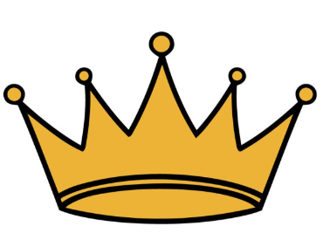
History – The Monarchy
Exploring the role of the Monarch and past and present monarchs
Data and information - Grouping Data
Introducing data and information, grouping objects based on their different properties.
Maths
White Rose

Multiplication and division – we will be focusing on counting in 2s, 5s and 10s, recognising and making equal groups and making arrays

Fractions – recognising and finding a half and quarter of an object or shape and a half and quarter of a quantity.

Position and direction – describe turns and positions

Problem solving and reasoning to deepen the children’s conceptual understanding.

English - Reading and Writing: The Secret of Black Rock

Reading:
Where the Wild Things Are- Maurice Sendak
The Secret of Black Rock – Joe Stanton

English writing:
Narrative and Information text – Where the Wild Things Are
Diary and Narrative – The Secret of Black Rock

Writing composition:
The children will have the chance to plan, draft and edit their writing.

Science – Seasonal climate change
This half term, the children will focus on understanding seasonal climate change. They will observe and describe the changes in weather associated with each of the four seasons and explore how day length varies throughout the year. Through hands-on activities and discussions, pupils will track and talk about how the weather changes over time, developing a deeper understanding of the natural patterns that occur in the UK’s seasons.

RE
Who is Muslim and how do they live? (continued)
Give good reasons for their ideas about whether prayer, respect celebration and self- control have something to say about them too.

Art Craft and Design – Woven wonders
Children will express opinions about art, use creative techniques like wool wrapping and weaving, and understand the work of artists like Cecilia Vicuña.

Music-Pitch
Learn how to identify high and low notes and to compose a simple tune to represent a superhero.

