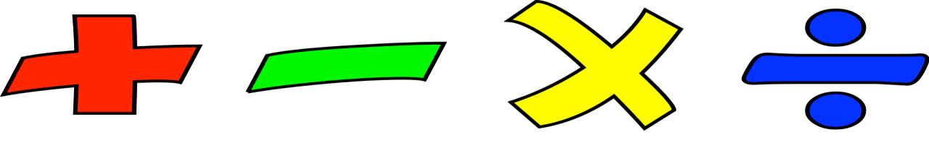
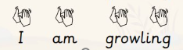
PSHE and RSE
Children will learn about keeping safe and understand that our bodies change as we grow, in ways that are natural and healthy.

Art – Sculpture and 3D: Paper play
children will explore their creative ideas using a range of art materials. They will use sketchbooks, practise drawing, painting and making, and talk about their own artwork and the work of others.
Music - Dynamics
Children will explore music through movement, voice and instruments. They will listen to and describe sounds, create loud and soft sounds using their bodies, voices and instruments, and follow instructions when performing. Children will also begin to create and play simple musical scores using symbols to show dynamics.
Humanities
History – Toys from the past
Children will learn about toys from the past and present. They will talk about their favourite toys, ask questions about toys from long ago, and compare them with toys they have today. Children will sequence toys from different time periods and explore how teddy bears have changed over the last 100 years.
Computing – Creating media – Digital writing
Children will create, edit, and format text, justifying their choices. They will also compare typing with handwriting, explaining their preference.
R.E
Children will learn about the ‘good news’ Christians believe Jesus brings by listening to Bible stories and understanding that the Gospel means good news.

PE
Children will explore dance by creating and performing simple movements to music, expressing their ideas and feelings.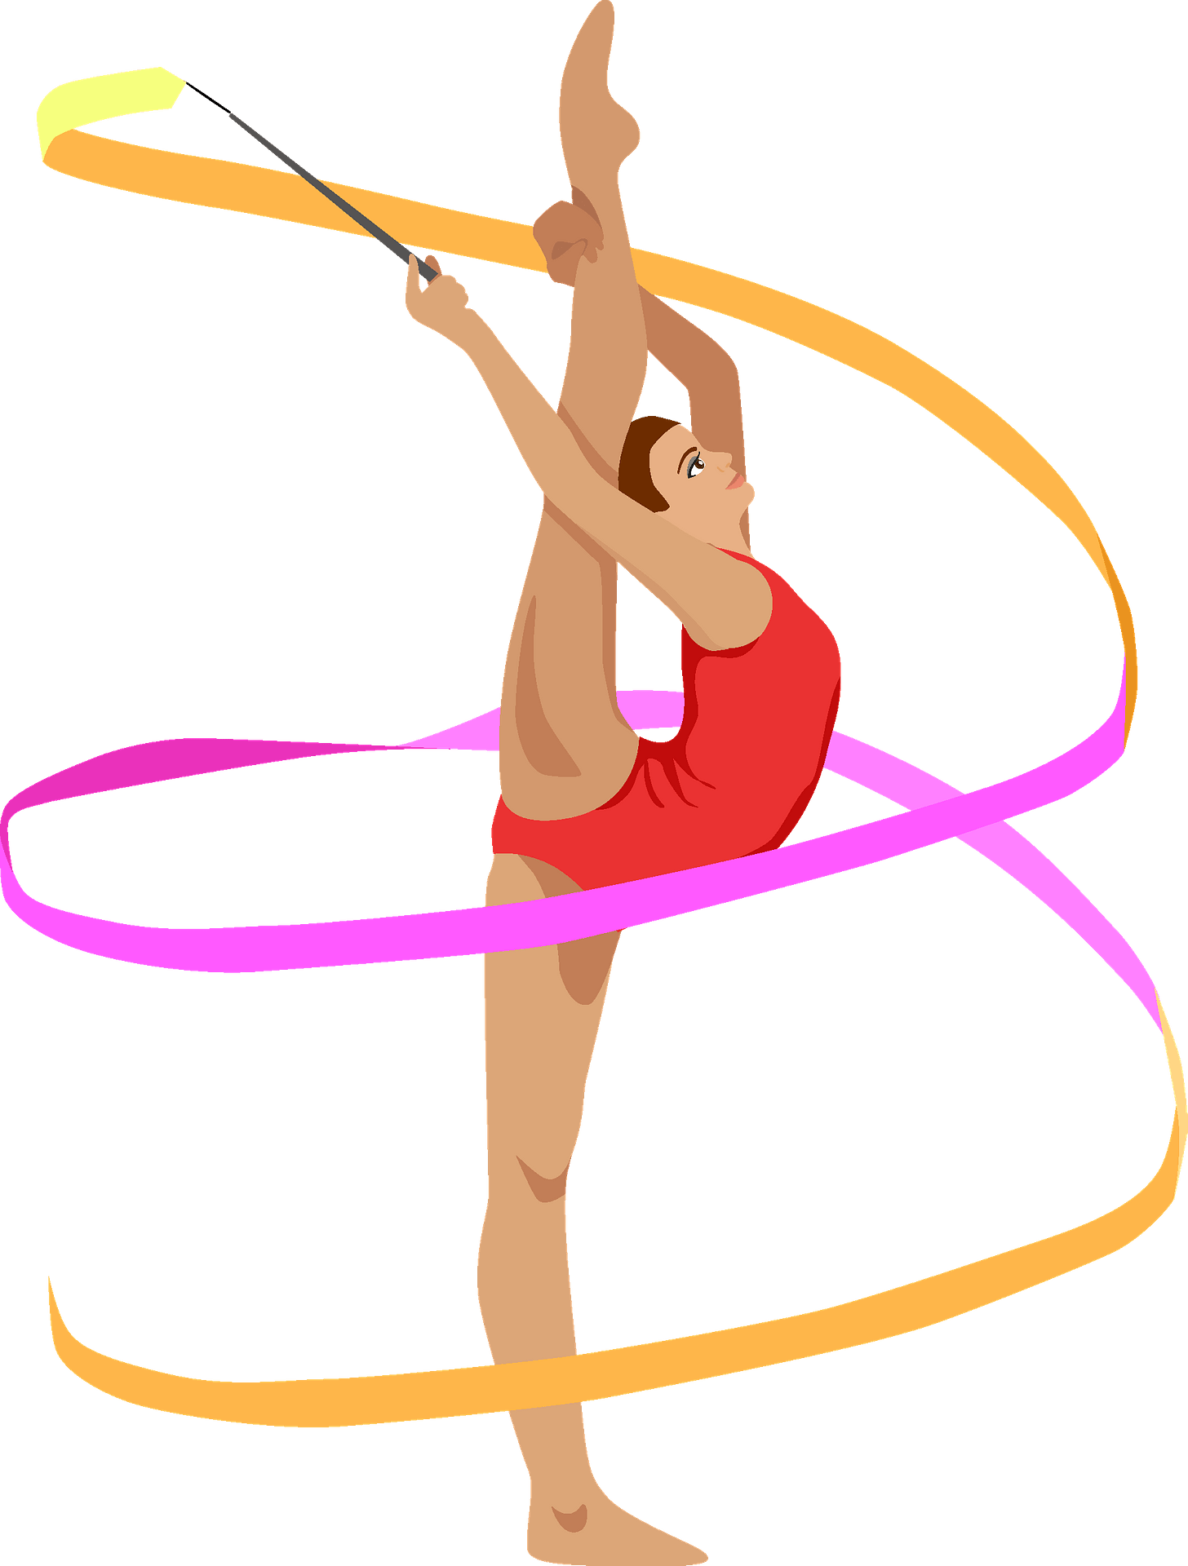

Science
Materials
This half term, children will learn about everyday materials. They will identify and name a range of common materials, such as wood, plastic, metal, glass, water and rock.
Children will explore the simple properties of materials, for example whether they are hard or soft, shiny or dull, rough or smooth, and waterproof or not. They will learn to describe materials using the correct scientific words and begin to group and compare materials based on what they are like and how they are used.

Year 1, Spring Term 2
Toys through time – How have toys changed?

Toys are an important part of childhood—but have they always looked and worked the same way? This term, children will explore the question: How have toys changed? They’ll begin by thinking about their own favourite toys, then compare them to the ones their parents and grandparents played with. Through stories, images and hands-on activities, children will discover what toys were like in the past and how materials, design and technology have changed over time. They’ll learn about the history of teddy bears and explore how toys reflect the time they were made in. By asking questions, making comparisons and sharing their ideas, children will build a picture of how play has evolved—and why toys still matter today.

Maths
White Rose
Place Value – children will learn about place value by counting, reading and writing numbers up to 50, and understanding tens and ones.

Addition and Subtraction – practise addition and subtraction within 10 and 20, using objects, pictures and number lines to help them.

Problem solving and reasoning - to deepen the children’s conceptual understanding.

English
Reading: Hermelin by Mini Grey

Writing genre:
Narrative – we will be writing a character description and retelling the vehicle text story of Hermelin by Mini Grey.

Letter writing - We will be writing a letter as Hermelin to a character from the text about their missing item.

Writing composition:
The children will have opportunities to plan, draft, write and edit their writing.

