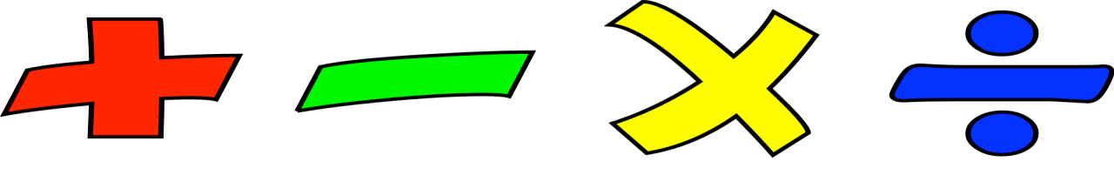
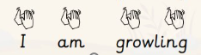
Humanities
Geography – What is it like to live here?
This term we will explore Earl Shilton, our school grounds and the local area, learning about human and physical features and drawing simple maps with basic symbols.
Computing - Data and Information – Grouping Data
Introducing data and information, grouping objects based on their different properties.
R.E
Who is a Muslim and how do they live?
We will learn about Muslim beliefs and ways of life, asking questions and sharing ideas.

Maths
White Rose
Place Value to 50 - recognise, represent and partition numbers up to 50, understanding tens and ones using practical resources and visual models.

Mass and Volume - will be learning to compare and measure mass and volume, using practical resources to explore heavier and lighter, and full and empty, as well as beginning to use standard units.

Problem solving and reasoning to deepen the children’s conceptual understanding.

Year 1, Spring Term 2
Where we Live
This term, Year 1 will be exploring Earl Shilton, our school grounds and the local area. The children will go on simple walks to observe human and physical features, learn about the difference between human and animal habitats, and begin to understand how our local environment is used. They will also develop their map skills by drawing simple maps, using basic symbols and creating simple keys.
PSHE and RSE
This term we will be learning about Citizenship. We will begin by focusing on the importance of rules. Then, we will focus on caring for animals and the needs of others. We will also look at ways we are the same/different to others.

Art – Sculpture and 3D
Next term, pupils will continue exploring creative ideas across a range of media, developing their skills with sketchbooks and gaining more control using tools for drawing, painting, crafts, and sculpture.
Music Sound Patterns – Fairytales
In this unit, children will use familiar fairytales to explore sound patterns (rhythms). They will clap along to repeated words and phrases and create simple rhythmic patterns to help retell a story.

Science
This half term, the children will study animals and humans, learning to label body and face parts and the senses associated with each. They will also identify common animals, including fish, amphibians, reptiles, mammals, and birds, as well as classify carnivores, herbivores, and omnivores.

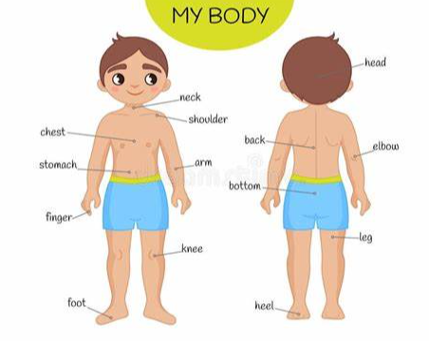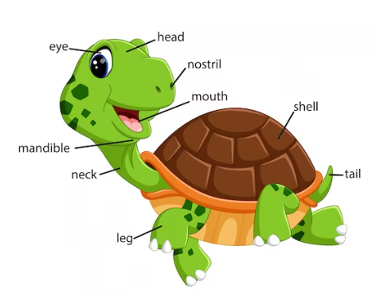

English
Reading: Where The Wild Things Are by Maurice Sendak

Writing genre:
Narrative – children will explore Where the Wild Things Are by reading and discussing the story, describing characters and settings, and retelling key events. They will practise writing simple sentences and create their own imaginative ideas inspired by the book

Writing composition:
The children will have opportunities to plan, draft, write and edit their writing.

PE
In PE this term we will be learning about twists and turns in gymnastics.
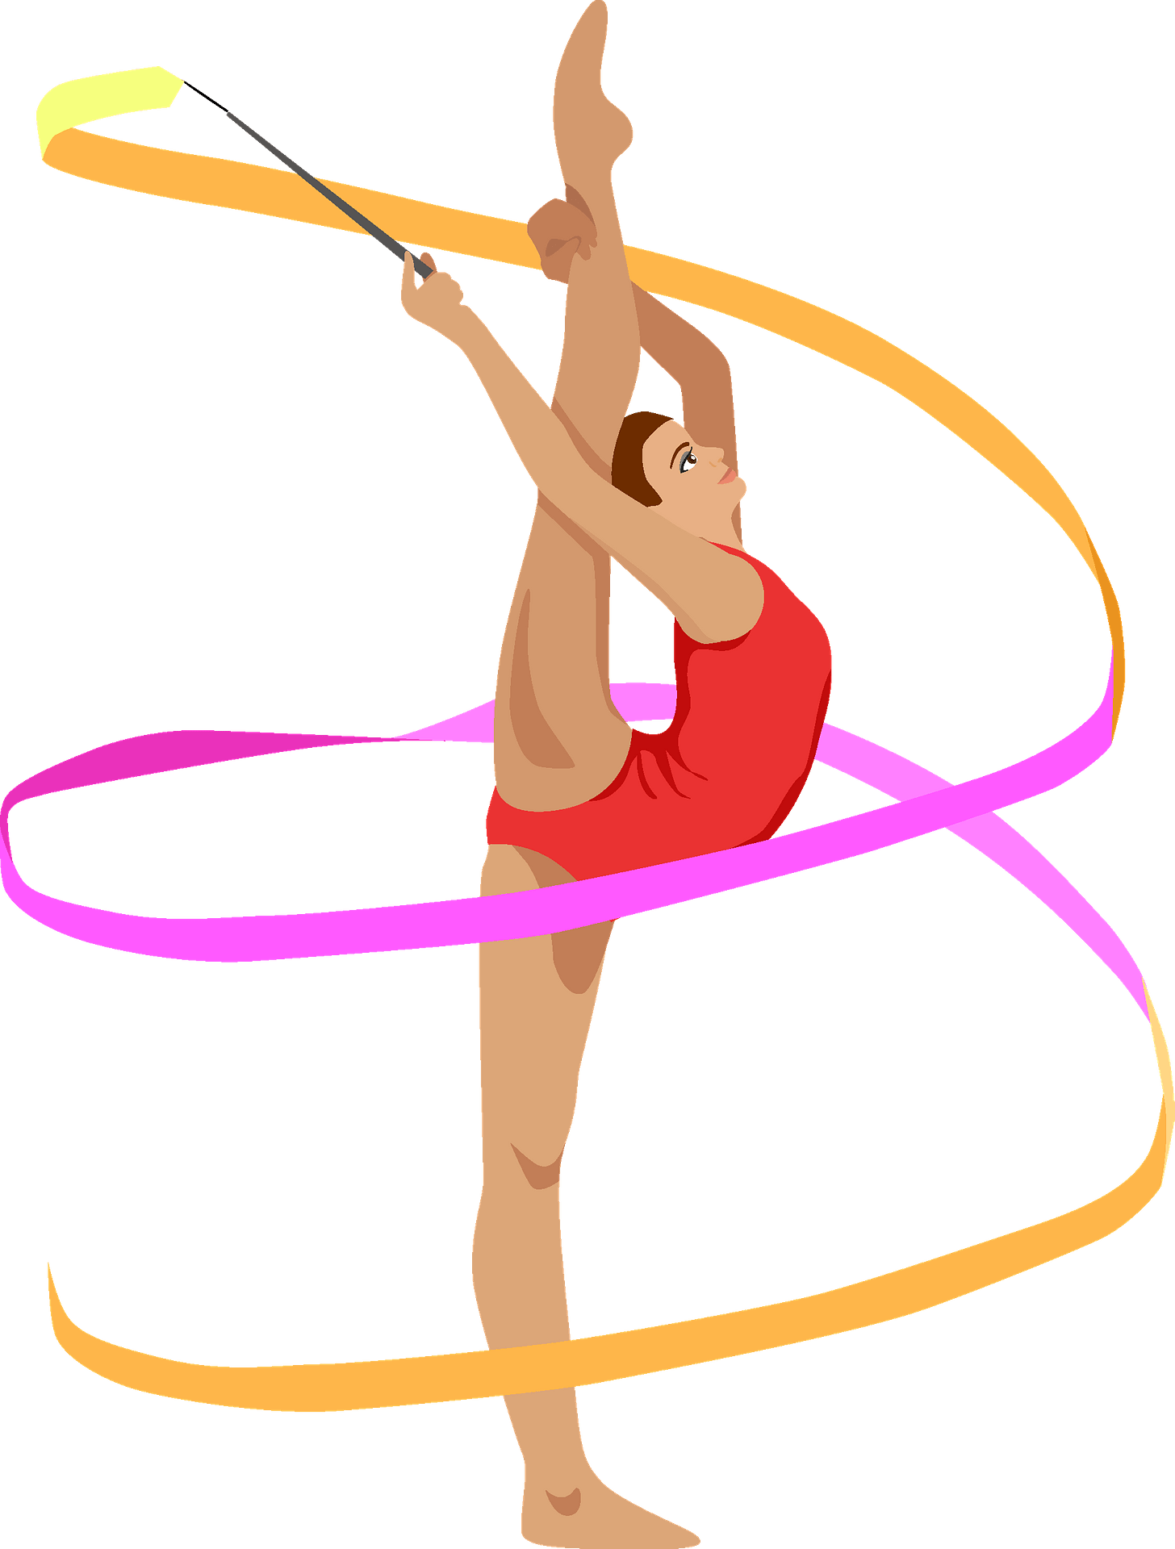

PSHE and RSE
This term we will be learning about Citizenship. We will begin by focusing on the importance of rules. Then, we will focus on caring for animals and the needs of others.

