
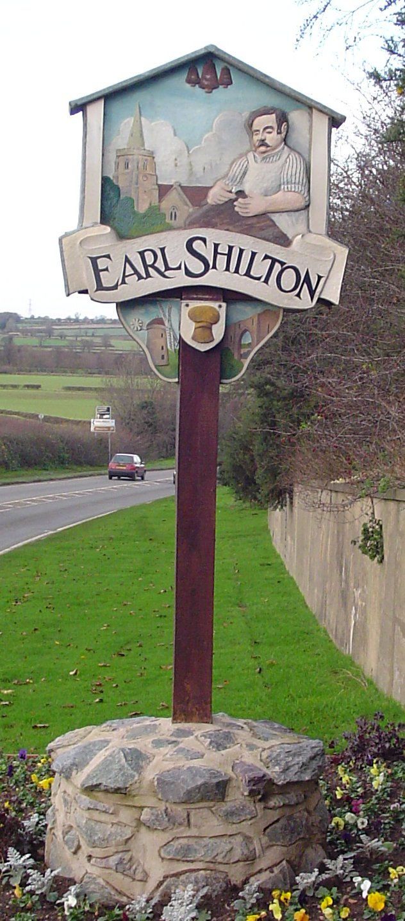

Townlands C of E Primary Academy
“A journey of learning in the light of God’s love”
Faith, Honesty, Love, Friendship, Forgiveness, Hope

“What shall we say the Kingdom of God is like, or what parable shall we use to describe it? It is like a mustard seed which is the smallest seed you plant in the ground. Yet when planted, it grows and becomes the largest of all garden plants, with such big branches that the birds of the air can perch in its shade.”

The parable of the Mustard seed- Mark 4:30-32


Year Two Spring Term 1 2026
Teachers: Miss Kendall & Mr Emmerson

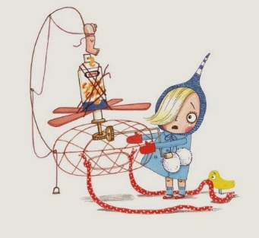
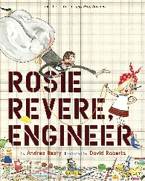
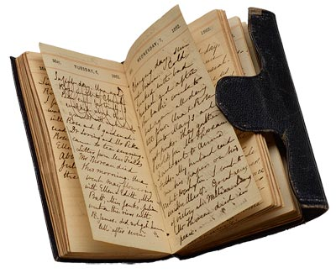

Welcome back! We hope you had an enjoyable Christmas break and are well rested in preparation for an exciting new half term of learning.
We have a busy half term of learning planned for the children as we will delve into how toys have changed over the last 100 years, identifying changes in living memory. Together, we will explore toys from different generations including the toys children currently play with, and the toys of their parents and grandparents.
In science, we will begin to explore the world around us through learning about plants. We will explore how bulbs and seeds grow over time. The children will take notes of what happens to the roots and all the variables that plants need to survive. Through our science lessons the children will observe their own class bulb. They will also have the opportunity to grow their own plant.
An invention narrative
Together we will use the story of Rosie Revere, Engineer to help us write a narrative around an invention
Rosie Revere, Engineer
In English this term we will be reading the story ‘The Night Gardener’ by The Fan Brothers. This is a beautiful story about a young boy called William, who discovers magical topiary growing in his garden. We will follow William uncover the treasures created by the Night Gardener.
An explanation text
Using the text in Rosie Revere, Engineer, we will write an explanation text on how to create an inventive creation.

Reading at home
We encourage the children to read at least five times a week and discuss what they have read with an adult. A reading record must be completed and signed by an adult.

Maths homework should be completed on MyMaths. Children will be expected to compete this weekly.

Spellings can be found on the school website and these will be tested in school on a Friday.
Homework and reading records will be checked every Friday morning.

PE:
P.E sessions will be taught weekly by our sports coach Mr Moon and Mr Emmerson. P.E will be taught on Tuesday afternoon by Mr Emmerson and Friday morning by Mr Moon.
It is important that the children wear their P.E. kit to school on these days. This needs to include an outdoor kit which is navy joggers, sweat shirt and trainers and indoor kit which is shorts, T-shirt and plimsols.
Health & Safety reminder: No jewellery to be worn during PE lessons, however if earrings can’t be removed then they need taping over. Children should bring their own tape and long hair tied up.


Water:
The children need to continue to bring to school fresh water (not juice) each day in a labelled bottle. It is important they do this because they do get thirsty throughout the day. We thank you for your cooperation with this.

Dates for your diary:
Friday 30th January – 2CE Class Assembly
Tuesday 10th February – Safer Internet Day

Keep looking at our page on the website for information and activities.
https://www.townlandsprimary.org/year-2/

If you have any queries or questions at any time, then please feel free to talk to us. This can this be done through a telephone call or an e-mail.
Finally keep an eye on Townlands Facebook posts for latest updates and successes.

