Year 2 Christmas homework task and spellings.
Maths
Please login to your MyMaths account for your maths homework. It is recommended that children access this resource ‘little and often’, therefore there is an expectation that children use this 3-5 times per week.
Spelling:
Please practise the following spelling words for the quiz next Friday. These will be based on sounds/words practised over the past weeks. Children should practise 1/2 lines of each word, focusing on joining their handwriting.
As a challenge, children should put each word into a sentence.
1. and
2. knee
3. kneel
4. knock
5. nail
6. sunny
7. funny
8. gnash
9. gnome
10. gnaw

Reading
Reading is incredibly important for children’s phonics sounds and their reading comprehension. Please read with your child 5 times (days) a week.
When your child is read with at home, please record this in children’s reading records and bring them into school every day.
If you have any issue accessing the homework, please let your class teacher know as soon as possible.

Christmas Diary:
Christmas is a very special and exciting time of year! Miss Kendall and Mr Emmerson would love to hear all about it. Therefore, your Christmas challenge is to write a diary to tell us about every exciting moment of every exciting day!


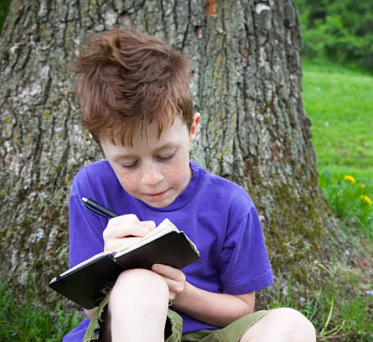

We wish you a merry Christmas and a happy New Year!


